FitBuddy – AI Fitness Plan Generator
PROJECT DOCUMENTATION
Naan Mudhalvan – Project Documentation
FastAPI + Google Gemini + SQLite
TEAM MEMBERS
1. Divyalakshmi S (Team Leader) – divyalakshmi.s.2025ds012@gmail.com
2. Jemi Ketzia S – jemi.ketzia.s.25ds019@gmail.com
3. Rishika R – rishika.r.25ds036@gmail.com
4. Janani V – janani.v.25ds017@gmail.com

1. PROJECT OVERVIEW
FitBuddy is a FastAPI and Google Gemini powered application designed to generate personalized 7-day workout plans and nutrition tips. The project also includes feedback-based plan revision and an admin dashboard for viewing users and plans.
The project is organized as a modular web application. The main FastAPI entry point, request models, database helpers, Gemini generators, route handlers, HTML templates, and static assets are separated into dedicated files and directories.
According to the README, the workout plan is generated through the Gemini 1.5 Pro path, while a Gemini 1.5 Flash path is used for the nutrition tip. Feedback-based revision is handled through a separate update module using Gemini 1.5 Pro.

Project Highlights
• Personalized 7-day workout plan generation
• Nutrition tip generation
• Feedback-based plan revision
• Admin view of all users and plans
• FastAPI backend with server-rendered templates
• Interactive Swagger UI for direct JSON API testing
Figure 1 presents the high-level architecture represented from the supplied folder structure and README description.
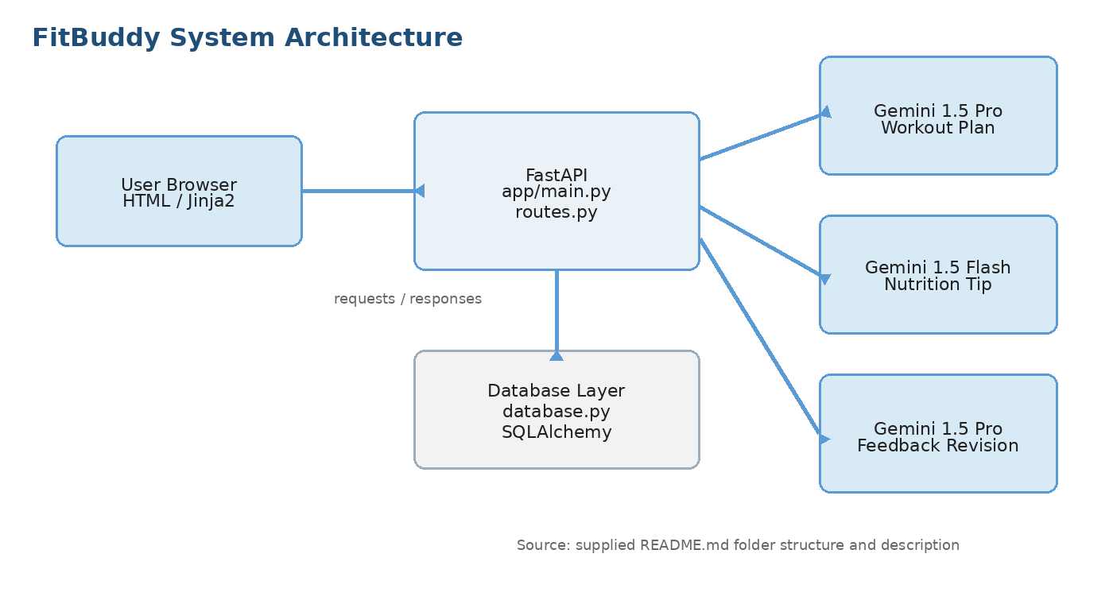
Figure 1: FitBuddy System Architecture

2. PROJECT OBJECTIVES
The primary goal of FitBuddy is to provide an automated way to create structured fitness plans and supporting nutrition guidance through a web application.
1. Generate a personalized 7-day workout plan from user inputs.
2. Provide a concise nutrition tip alongside the generated plan.
3. Allow a generated plan to be revised using user feedback.
4. Keep workout, nutrition, revision, routing, templates, and database responsibilities modular.
5. Provide an admin view for stored users and plans.
6. Expose the backend through FastAPI, including Swagger-based API exploration at /docs.

3. APPLICATION SCENARIOS

3.1 Personalized Workout Planning
A user accesses the main application page, provides the required input, and submits the form. The FastAPI application routes the request to the workout generator, which uses Gemini 1.5 Pro to produce the 7-day plan.

3.2 Nutrition Guidance
The application also generates a nutrition tip using the Gemini Flash generator. The README describes this output as a low-cost, fast, one-line response.

3.3 Feedback-Based Revision
After receiving a plan, the user can provide feedback and request a revised version. The updated_plan.py module sends the revision task through Gemini 1.5 Pro.

3.4 Administrative Viewing
The admin dashboard is exposed through the /view-all-users page and is intended to present all users and plans in a table-oriented view.

4. SYSTEM ARCHITECTURE
FitBuddy follows a modular web architecture in which the browser-facing templates communicate with a FastAPI backend. The backend routes requests to the appropriate generator or database helper and then returns the resulting content to the user interface.

Architecture Components
Layer | Source component | Responsibility
Web interface | templates/index.html, result.html, all_users.html | Render the main input page, generated result page, and admin user/plan view.
Backend | app/main.py, routes.py | Start the FastAPI application and handle route-level request processing.
Request/data models | schemas.py | Define Pydantic request models.
AI generation | gemini_generator.py | Generate the workout plan with Gemini 1.5 Pro.
Nutrition generation | gemini_flash_generator.py | Generate the nutrition tip with Gemini Flash.
Revision | updated_plan.py | Revise the plan from feedback using Gemini 1.5 Pro.
Persistence | database.py, fitbuddy.db | Provide SQLAlchemy models and database helpers; the database file is auto-created on first run.
Static assets | static/images/ | Store application image assets.
The components connect through routes rather than placing all application behavior in a single file. This separation supports maintenance of individual project features.

5. SOFTWARE AND HARDWARE REQUIREMENTS

5.1 Software Requirements
• Python
• FastAPI
• Uvicorn
• Jinja2
• SQLAlchemy
• Google Generative AI Python package
• python-dotenv
• python-multipart
• Visual Studio Code or another Python-capable IDE
• Web browser

5.2 Hardware and Connectivity Requirements
The project must run a Python environment capable of hosting the FastAPI application and its dependencies. Because Gemini is accessed through an API, stable internet connectivity is required for the cloud AI operations.
The required processing capacity depends on the Python packages and the application workload. The supplied project files do not specify a fixed CPU, RAM, or storage minimum, so no hardware numbers are stated here.

5.3 Environment Requirements
A virtual environment is recommended by the README for installing the project dependencies in an isolated Python environment.

6. TECHNOLOGY STACK
Technology | Role in FitBuddy
Python | Primary programming language for the application backend and supporting modules.
FastAPI | Backend framework and request/response layer.
Uvicorn | Application server used to start the FastAPI app.
Jinja2 | Template engine used for server-rendered HTML pages.
SQLAlchemy | Database model and helper layer used by database.py.
Google Generative AI | Python package used to communicate with Gemini models.
Gemini 1.5 Pro | Workout-plan generation and feedback-based plan revision.
Gemini 1.5 Flash | Nutrition-tip generation.
python-dotenv | Loads environment configuration from .env.
python-multipart | Included as a project dependency for FastAPI form/multipart support.
HTML/CSS | Frontend markup and styling used by the template-based web interface.
The supplied requirements.txt contains the project dependencies listed above. No package outside the supplied requirements file is assumed in this documentation.

7. AI MODEL SETUP
FitBuddy uses two Gemini model paths with separate responsibilities.

7.1 Gemini 1.5 Pro
The README states that Gemini 1.5 Pro is used for the workout plan and feedback-based revisions. The model is selected because the project needs to follow structured formatting reliably for the main plan output.

7.2 Gemini 1.5 Flash
Gemini 1.5 Flash is used for the nutrition tip. The README describes this path as a fast and inexpensive option intended for one-line output.

7.3 Model Configuration Files
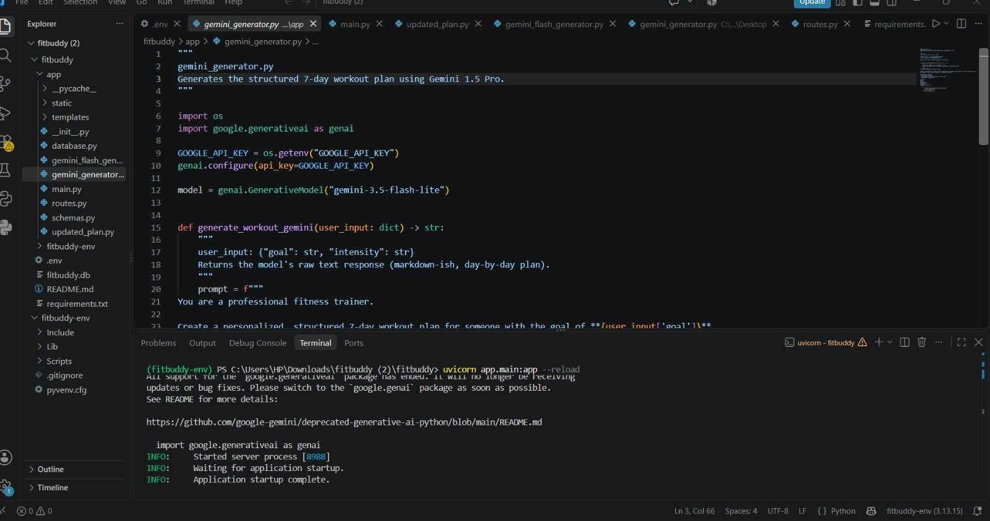
Figure 6: Gemini Configuration and FastAPI Server Running in VS Code
File | AI responsibility
app/gemini_generator.py | Workout plan generation.
app/gemini_flash_generator.py | Nutrition tip generation.
app/updated_plan.py | Feedback-based plan revision.
The README also notes that model names may need to be changed when an API key tier no longer exposes the specified model names. The replacement model should be applied consistently in the three generator files named above.

7.4 Workout Plan Flow
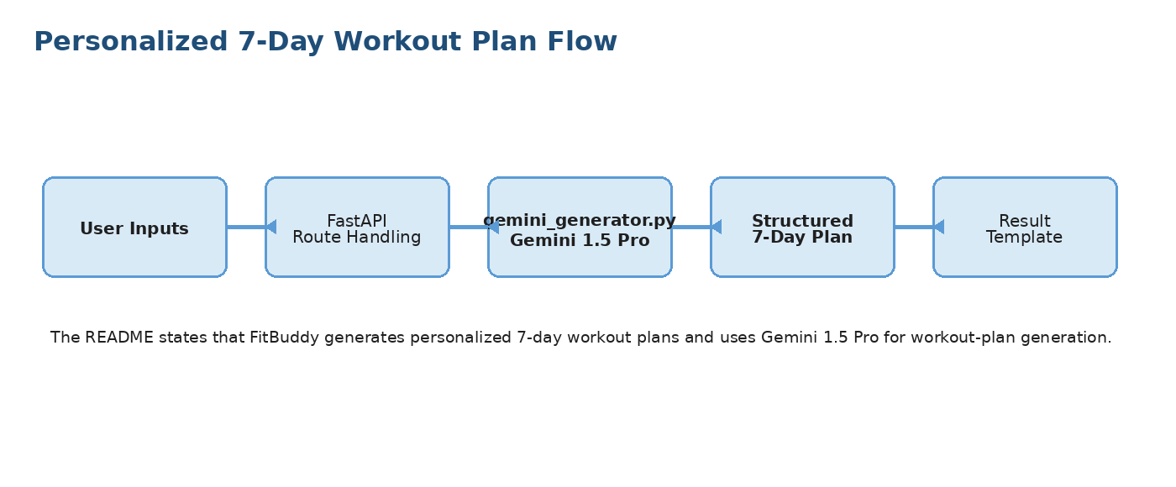
Figure 2: Personalized 7-Day Workout Plan Flow

8. PROJECT STRUCTURE
The FitBuddy repository is organized so that application startup, data models, schemas, AI generators, routes, templates, static assets, and the database file are separated by responsibility.
fitbuddy/
├── requirements.txt
├── .env.example
├── app/
│ ├── main.py # FastAPI entry point
│ ├── database.py # SQLAlchemy models + DB helpers
│ ├── schemas.py # Pydantic request models
│ ├── gemini_generator.py # Gemini 1.5 Pro - workout plan
│ ├── gemini_flash_generator.py # Gemini Flash - nutrition tip
│ ├── updated_plan.py # Gemini 1.5 Pro - feedback revision
│ ├── routes.py # Route handlers
│ ├── templates/
│ │ ├── index.html
│ │ ├── result.html
│ │ └── all_users.html
│ └── static/
│ └── images/
└── fitbuddy.db # auto-created on first run

Module Responsibilities
main.py: Contains the FastAPI entry point.
database.py: Contains SQLAlchemy models and database helpers.
schemas.py: Contains Pydantic request models.
gemini_generator.py: Handles workout-plan generation with Gemini 1.5 Pro.
gemini_flash_generator.py: Handles the nutrition-tip generation path.
updated_plan.py: Handles feedback-based plan revision.
routes.py: Contains the route handlers that connect requests to application modules.
templates/: Contains the HTML pages rendered by the application.
static/images/: Contains image assets.
fitbuddy.db: Local database file auto-created on first run.

9. CORE FUNCTIONAL MODULES

9.1 Workout Plan Generator
The workout-plan feature is the primary generation workflow. A request is received by FastAPI, passed through the route layer, and handled by gemini_generator.py. The generator uses Gemini 1.5 Pro to create a personalized 7-day workout plan. The generated result is then presented through the result template.

9.2 Nutrition Tip Generator
The nutrition workflow is handled separately by gemini_flash_generator.py. This separation allows the short nutrition response to use the Flash model path rather than the Pro generation path.
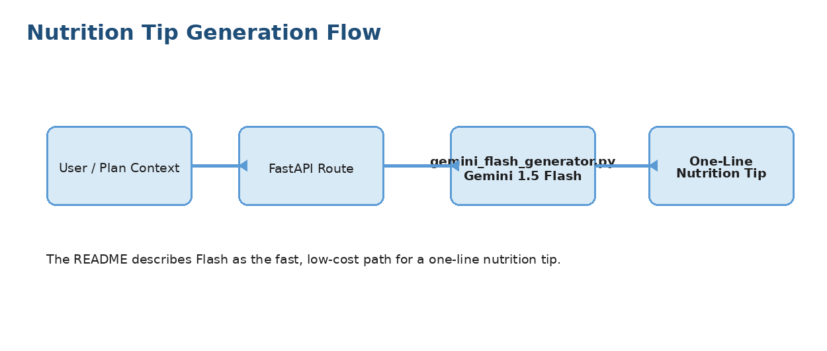
Figure 3: Nutrition Tip Generation Flow

9.3 Feedback-Based Revision
The revision workflow takes an existing plan and user feedback and uses the updated_plan.py module to generate an updated result with Gemini 1.5 Pro.
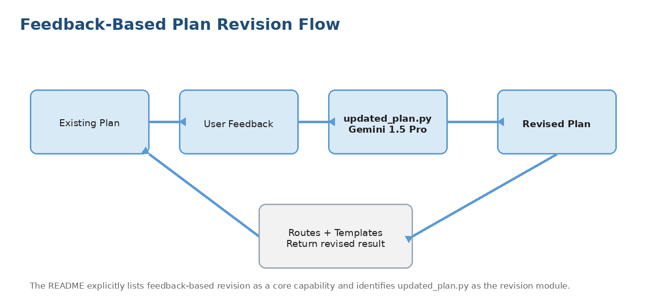
Figure 4: Feedback-Based Plan Revision Flow

10. FASTAPI BACKEND IMPLEMENTATION
FastAPI acts as the central communication layer of FitBuddy. The README identifies app/main.py as the entry point and app/routes.py as the location of route handlers.

10.1 Backend Responsibilities
• Start the FastAPI application.
• Receive requests from the web interface.
• Pass requests to the appropriate generator, revision module, or database helper.
• Return the generated result to the relevant HTML view.
• Expose the JSON API through FastAPI and make it testable through Swagger UI at /docs.

10.2 Application Pages Mentioned in the README
URL | Purpose
http://127.0.0.1:8000/ | Input form for generating the 7-day plan and nutrition tip.
http://127.0.0.1:8000/view-all-users | Admin table showing all users and plans.
http://127.0.0.1:8000/docs | Swagger UI for testing the JSON API routes directly.

10.3 Request-to-Response Pattern
The intended pattern is: browser request -> FastAPI route -> relevant application module -> Gemini and/or database layer -> generated response -> HTML template.
The supplied README does not enumerate the exact request parameters or JSON response schemas for each route, so this documentation does not invent endpoint payloads that are not present in the provided files.

11. DATABASE AND ADMIN DASHBOARD

11.1 Database Layer
The project structure identifies database.py as the location for SQLAlchemy models and database helpers. A fitbuddy.db database file is listed at the project root and is auto-created on first run.

11.2 Data Usage in the Application
The README states that the admin dashboard displays all users and plans. This means the database layer supports the information needed for administrative viewing of stored user/plan records.

11.3 Admin Dashboard Flow
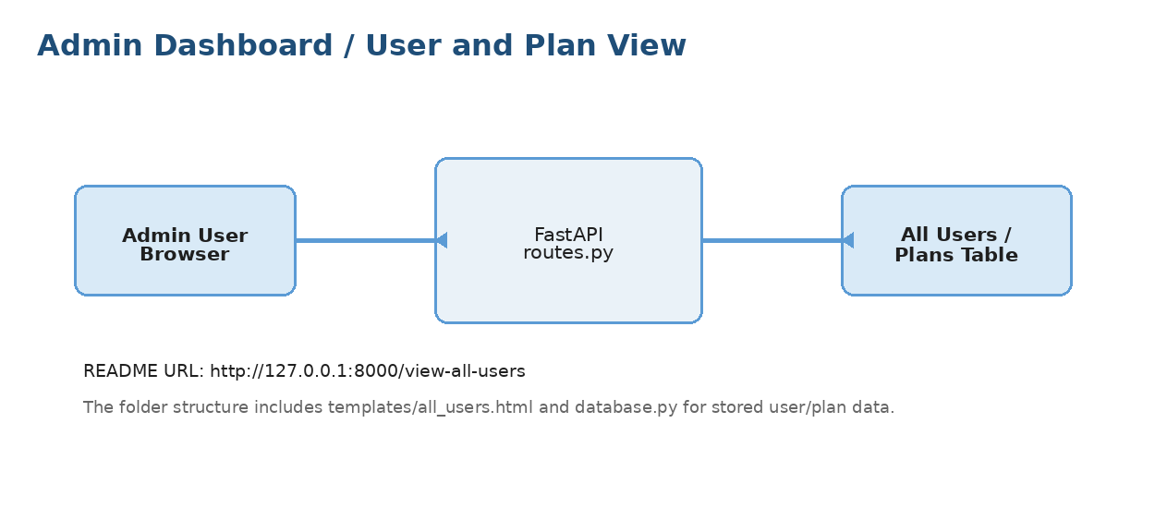
Figure 5: Admin Dashboard and User/Plan View
The supplied source files do not specify authentication or authorization rules for the admin page, so none are assumed in this documentation.

12. USER INTERFACE DEVELOPMENT
The FitBuddy interface is implemented with Jinja2 templates under app/templates and static assets under app/static/images.
Template | Documented role
index.html | Main user input page used to start plan generation.
result.html | Page used to present the generated 7-day plan and nutrition tip.
all_users.html | Admin table for all users and plans.

Interface Characteristics
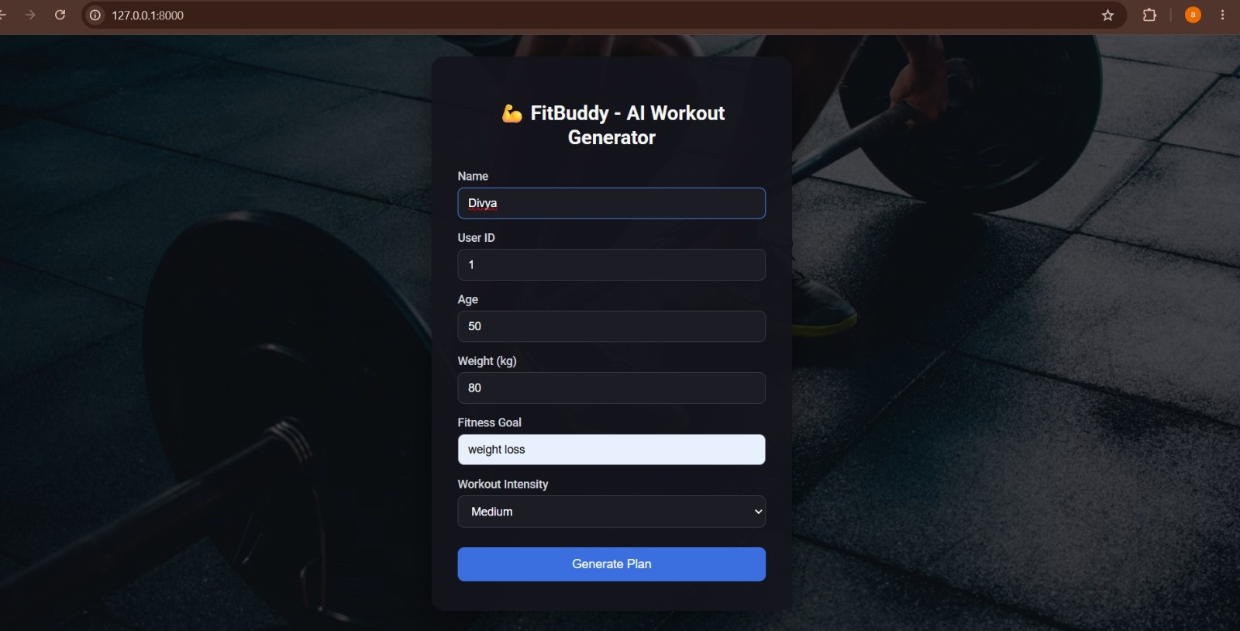
Figure 7: FitBuddy Main User Interface
• Template-based HTML pages served through the FastAPI application.
• Input-to-result workflow centered on the main page and result page.
• Dedicated administrator-oriented page for users and plan records.
• Static image assets grouped under the application static directory.
The supplied files do not contain the HTML/CSS source itself, so visual claims such as exact colors, layouts, form fields, or responsive behavior are not documented here.

13. APPLICATION SETUP AND EXECUTION

13.1 Create a Virtual Environment
python -m venv fitbuddy-env
fitbuddy-env\Scripts\activate # Windows
source fitbuddy-env/bin/activate # macOS/Linux

13.2 Install Dependencies
pip install -r requirements.txt

13.3 Configure the Gemini API Key
cp .env.example .env
# edit .env and set:
GOOGLE_API_KEY=your_actual_key_here
The application reads the Gemini credential from an environment variable. Keep the real credential private and do not place it in public source files.

13.4 Start the Server
uvicorn app.main:app --reload

13.5 Open the Application
http://127.0.0.1:8000/
These commands are the setup and execution steps provided in the supplied README.

14. USING THE APPLICATION

14.1 Main Generation Page
Open the root application URL in a browser. The main input form is designed to start the FitBuddy generation workflow. The output consists of a 7-day workout plan and a nutrition tip.

14.2 Result Page
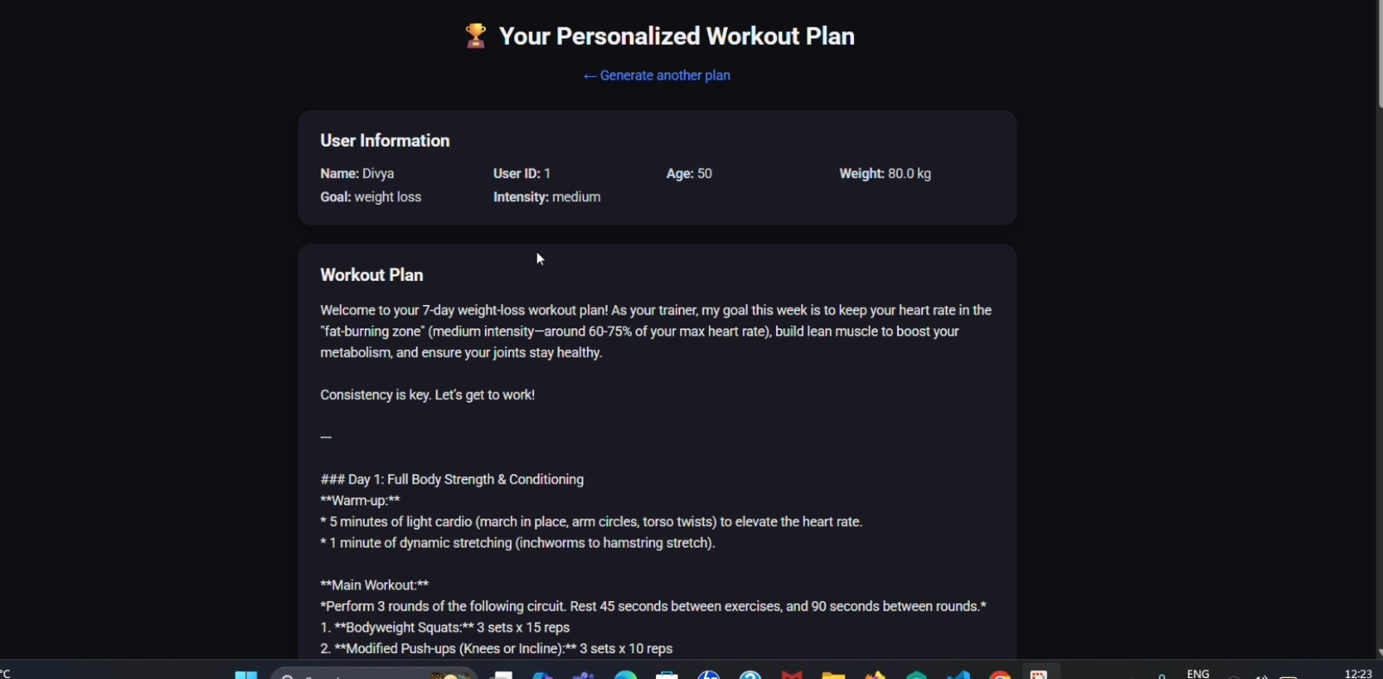
Figure 8: Generated Personalized 7-Day Workout Plan
The generated content is presented through result.html after the request is processed by the backend.

14.3 Feedback and Revision
Where the application exposes the feedback workflow, the existing plan can be revised through the separate updated_plan.py module using Gemini 1.5 Pro.

14.4 Admin View
Open /view-all-users to access the table-oriented view of all users and plans described in the README.

14.5 Swagger API Testing
Open /docs to access FastAPI Swagger UI. The README specifically identifies this page as the place to test JSON API routes directly.

15. CONFIGURATION AND ENVIRONMENT VARIABLES

15.1 Environment File
The supplied .env.example defines the GOOGLE_API_KEY environment variable. The documented setup flow copies .env.example to .env and replaces the example value with the actual Gemini API key.
GOOGLE_API_KEY=your_actual_key_here

15.2 Credential Handling
The environment file exists so credentials can be kept outside the application source code. The actual key value from the supplied example file is intentionally not reproduced in this documentation.

15.3 Model Availability Note
The README warns that gemini-1.5-pro and gemini-1.5-flash may not be available for every API-key tier. When a model is deprecated or unavailable, the README directs the project maintainer to replace the model name in gemini_generator.py, gemini_flash_generator.py, and updated_plan.py.

16. DEPENDENCY MANAGEMENT
The project keeps its Python dependencies in requirements.txt. Installing this file after activating the virtual environment is the documented setup path.
Package | Purpose represented by project structure/setup
fastapi | Web backend framework.
uvicorn[standard] | ASGI server used to run the application.
jinja2 | HTML template rendering.
sqlalchemy | Database models and database helpers.
python-multipart | Multipart/form support dependency included by the project.
google-generativeai | Gemini API integration.
python-dotenv | Environment variable loading.

Installation Command
pip install -r requirements.txt
The supplied requirements file is intentionally treated as the authoritative dependency list for this documentation.

17. OPERATIONAL AND MAINTENANCE NOTES

17.1 Keep the Gemini Credential Configured
The Gemini API key must be available through the GOOGLE_API_KEY environment variable before the Gemini-powered functions can operate.

17.2 Monitor Model Availability
The README explicitly identifies model deprecation as a possible maintenance task. If a selected model is not available to the configured API key, the generator files should be updated to a currently supported model.

17.3 Preserve Module Separation
The project structure separates workout generation, nutrition generation, feedback revision, database access, routing, and templates. Keeping these responsibilities separated makes changes easier to isolate.

17.4 Use the Built-In API Documentation
The /docs page provides an interactive Swagger UI for the JSON API. It can be used to inspect and test the routes exposed by the running FastAPI application.

17.5 Scope of This Documentation
This documentation is based only on the supplied README.md, requirements.txt, and .env.example files. Source files such as main.py, routes.py, database.py, schemas.py, and the HTML templates were not supplied, so implementation details beyond the project structure are not stated as facts.

PROJECT REPOSITORY LINK

https://github.com/divyalakshmis2025ds012-stack/FitBuddy

